Live Migration Cutover Decision & Status Verification Metrics Design Document
Status: In Review
Authors: Darshan Siddesh Jagaluru
Last Updated: Jul 29, 2026

#begin-approvals-addon-section
Username | Role | Status | Last change
adibh | Approver | 🟡 Pending | Jul 17, 2026
manitgupta | Approver | 🟡 Pending | Jul 17, 2026
khajanchi | Reviewer | 🟡 Pending | Jul 17, 2026
shrutipurohit | Reviewer | 🟡 Pending | Jul 17, 2026

 | Approval Instructions: Please approve or LGTM through the G3 Assist sidebar.  For more information, see go/g3a-approvals-reviewing

1. Objective
Performing a migration cutover is a high-stakes, time-critical operation. During the cutover process, customers must take two important decisions:

- Starting the cutover: Is the CDC replication pipeline caught up to begin the cutover?
- Ending the downtime: Once application writes cease, has every single transaction in source successfully replicated to Spanner without data loss?

Since our current live migration architecture runs as a composition of cloud services in the customer GCP account, customers are naturally exposed to dozens of individual component-level metrics. This creates confusion and it’s hard to figure out the relevant metrics required to make the above decisions.
This document addresses this complexity by identifying the metrics required, and providing a simplified dashboard view to guide the cutover decisions.

2. Cutover decision making algorithm
The cutover decision-making is a deterministic algorithm based on 6 Boolean conditions. Each Boolean condition needs to be manually evaluated by the customer by observing a graph in the cutover dashboard or by running a command gcloud CLI command or executing a SQL query. The algorithm and the details will be given to the customers in the cutover playbook Google cloud documentation page.

2.1 Starting the Cutover Decision
The decision to start the cutover and initiate application downtime is YES if and only if all 6 Boolean conditions evaluate to TRUE simultaneously:

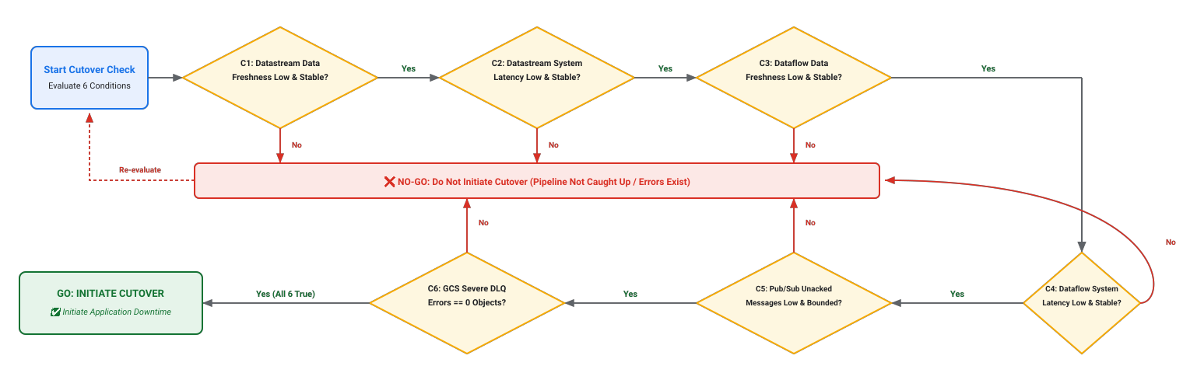

2.2 Ending the Downtime
The procedure to perform the cutover is as follows:
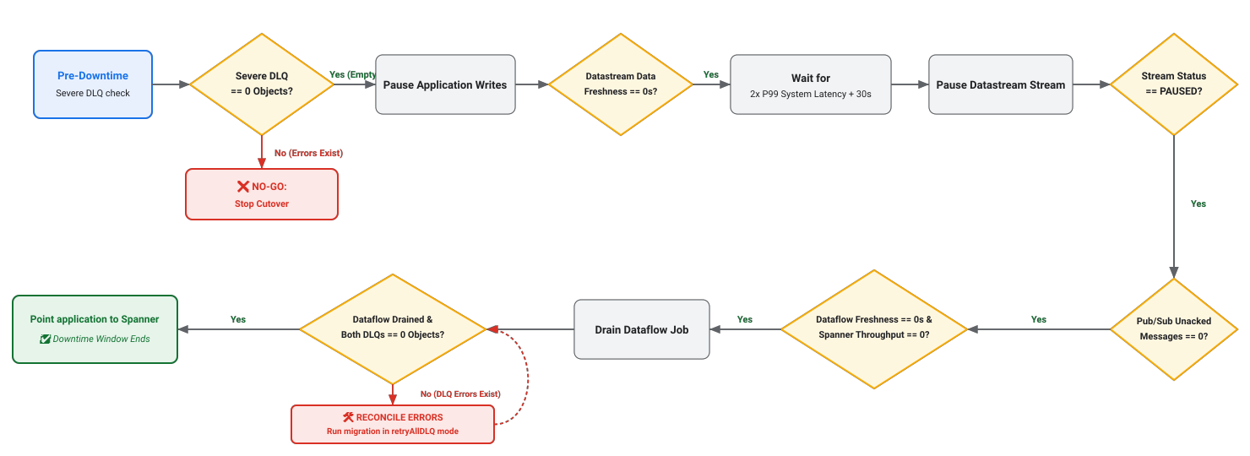

3. Cutover Dashboard
The identified metrics will be plotted in a custom Cloud Monitoring dashboard in the customer's GCP project. Similar to other migration tools, this Cloud Monitoring dashboard will also be created via a Terraform template. Specifically, creation of the dashboard step will be appended as a last step in the live migration terraform templates. Upon execution completion, the Terraform template outputs the direct GCP Console URL of the dashboard.

3.1 Panel Layout & Positioning
The dashboard organizes the metrics into 3 panels:
• Panel 1 - Datastream - Datafreshness, System latency
• Panel 2 - Dataflow - Datafreshness, System latency, throughput
• Panel 3 - Pub/Sub unacknowledged message count.

All the panels above will share the timescale, and the plots will be for the last 3 days by default.

Note: The GCS DLQ error object counts are obtained via manual GCS CLI queries (gsutil ls). Details on how to query these will be provided to customers in the cutover runbook in public documentation. These metrics will not be displayed on the Cloud Monitoring dashboard.

4. Key Dimensions for cutover
We need to understand core dimensions which indicate if a pipeline is healthy and ready to cutover.
- Backlog (Pending Work): The amount of unapplied change data buffered across various stages.
- Replication Lag (Time Delay): The time taken by the system to process a record.
- Errors & Integrity (Exceptions): Tracking of failed events that could not be applied.

In this section, we will identify the metrics from the components of our live migration pipeline which help us measure the above three dimensions. For each dimension, we show the exact metric we are interested in and how to verify it during cutover.

System | Dimension | Metric | Downtime Start Condition | Downtime End Condition
Datastream | Backlog | Datastream Data Freshness | Must hold a stable, low steady-state without upward spikes. | Must converge to exactly 0s for at least 2 consecutive 1-minute aggregation periods
Datastream | Replication lag | Datastream System Latency | Must hold a stable, low steady-state (<SLA) | Used to compute post-pause wait time (2x P99 + 30s)
Dataflow | Backlog | Dataflow Data Freshness | Must hold a stable, low steady-state without upward spikes. | Must converge to exactly 0s for at least 2 consecutive 1-minute aggregation periods
Dataflow | Backlog | Spanner write stage throughput | NA | Must converge to exactly 0s for at least 2 consecutive 1-minute aggregation periods
Dataflow | Replication lag | Dataflow System Latency | Must hold a stable, low steady-state (<SLA) | NA
Pub/Sub | Backlog | Pub/Sub Unacked message count | Must remain low and bounded | Must drop to exactly 0 for at least 2 consecutive 1-minute aggregation periods
GCS | Errors & Integrity | gcloud storage ls command on severe/ and retry/ directory | Must strictly equal 0. Any objects residing in the GCS severe/ DLQ folder block cutover. | Exactly 0 objects in both severe/ and retry/ folders after Dataflow is drained for at least 2 consecutive 1-minute intervals

5. Sharded Migrations
In sharded migrations, we have two kinds of architectures which customers can use. The metrics and dashboards are handled as follows:

5.1 Multi-Dataflow Job Setup Pattern
A dataflow job is set up for each MySQL shard during the live migration.
- Metric Dashboards: We will create a unique metric dashboard for each Dataflow job.
- Cutover Process: Each Dataflow job, corresponding to each shard, will be cutover individually. Customers use each shard's dedicated dashboard to monitor and make cutover decisions for that specific shard.

5.2 Shared Dataflow Job Architecture
One dataflow job handles live migration for all the shards. Each MySQL instance will have a unique datastream set up, and all the streams would be writing events to a common GCS location -> consumed by only one Dataflow job.
- Metric Dashboards: We will create only one metric dashboard.
- Consolidated View: The single dashboard will contain all the information and metrics for all the shards, allowing customers to monitor the entire system and perform cutover for all the shards. Since, there will be one datastream panel for each stream (shard) in the monitoring dashboard.

6. Reverse replication cutback

6.1 Starting the cutback Decision
The decision to start the cutback and initiate application downtime is YES if and only if all 4 Boolean conditions evaluate to TRUE simultaneously:

C1. GCS DLQ Severe Errors is zero
C2. Dataflow data freshness is stable and low
C3. Dataflow system latency is stable and low
C4. Pub/Sub Unacknowledged Message Count is low and bounded

6.2 Ending the Downtime
The procedure to perform the cutback is as follows:

1. Verify GCS DLQ Severe Errors is zero
2. Pause Application writes
3. Wait till Pub/Sub Unacknowledged Message Count drops to zero
4. Wait till Dataflow throughput drops to zero
5. Stop the Dataflow job
6. Verify GCS DLQ Severe and Retry Errors remain zero
7. Run reverse replication job in retryAllDLQ mode if GCS DLQ has some events

6.3. Cutback Dashboard
Creation of the dashboard step will be appended as a last step in the reverse replication terraform templates.

6.3.1 Panel Layout & Positioning
The dashboard organizes the metrics into 2 panels:
• Panel 1 - Dataflow - Datafreshness, System latency, throughput
• Panel 2 - Pub/Sub unacknowledged message count.

All the panels above will share the timescale, and the plots will be for the last 3 days by default.

Note: The GCS DLQ error object counts are obtained via manual GCS CLI queries (gsutil ls). Details on how to query these will be provided to customers in the cutback runbook.

6.4. Cutback metrics

System | Dimension | Metric | Downtime Start Condition | Downtime End Condition
Dataflow | Backlog | Dataflow Data Freshness | Must hold a stable, low steady-state without upward spikes. | Must converge to exactly 0s for at least 2 consecutive 1-minute aggregation periods
Dataflow | Backlog | Dataflow throughput | NA | Must converge to exactly 0s for at least 2 consecutive 1-minute aggregation periods
Dataflow | Replication lag | Dataflow System Latency | Must hold a stable, low steady-state (<SLA) | NA
Pub/Sub | Backlog | Pub/Sub Unacked message count | Must remain low and bounded | Must drop to exactly 0 for at least 2 consecutive 1-minute aggregation periods
GCS | Errors & Integrity | gcloud storage ls command on severe/ and retry/ directory | Must strictly equal 0. Any objects residing in the GCS severe/ DLQ folder block cutover. | Exactly 0 objects in both severe/ and retry/ folders after Dataflow is drained for at least 2 consecutive 1-minute intervals

6.5. Sharded Migrations handling
The one reverse replication dataflow job can handle multiple shards of MySQL. The cutback metrics don’t have any shard specific graphs and one dashboard will be created for every reverse replication dataflow job.

7. Appendix

Metrics for Deep-Dive and Troubleshooting
While the metrics above helps us make cutover decisions, customers can utilize the following detailed component-level metrics for deep-dive and troubleshooting

Source MySQL

• Binlog Head Position (SHOW MASTER STATUS / SHOW BINARY LOG STATUS):
- What it actually means: The active binary log filename (e.g., mysql-bin.000124) and exact byte offset (Position: 891234) where MySQL is currently writing new committed transactions right now.
- How we get / query it: Execute query directly against the MySQL primary instance: SHOW MASTER STATUS; (In MySQL 8.0.22+, execute SHOW BINARY LOG STATUS;).
- Cutover Evaluation: When application is stopped during cutover, querying SHOW MASTER STATUS twice 60 seconds apart must return the exact same File and Position both times. A frozen position proves zero new writes are hitting the database.

* Binlog Durability & Commit Ordering Triad
- What it actually means: The three critical system variables that dictate whether uncommitted/committed transactions sitting in Linux OS memory page cache are synchronously flushed to the hard drive (fsync()) on commit, and whether commit serialization order inside the binary log strictly matches InnoDB storage engine order during parallel group commits.
- How we get / query it: Execute against the MySQL primary instance: SHOW VARIABLES WHERE Variable_name IN ("sync_binlog", "innodb_flush_log_at_trx_commit", "binlog_order_commits");
- Cutover Evaluation: All three variables MUST equal 1 (sync_binlog = 1, innodb_flush_log_at_trx_commit = 1, binlog_order_commits = 1). If sync_binlog = 0, a server crash or power failure while events reside in the OS memory cache will cause transactions to be lost from the binlog—even though the application received COMMIT OK—creating unrecoverable data corruption between MySQL and Cloud Spanner.

* Binlog File Retention

- What it actually means: The system variable dictating how long binary log files are retained on the hard drive before MySQL automatically purges them to reclaim disk space.
- How we get / query it: Execute against the MySQL primary instance: SHOW VARIABLES LIKE "binlog_expire_logs_seconds"; (For legacy MySQL 5.7, query SHOW VARIABLES LIKE "expire_logs_days"; where 1 day = 86400 seconds).
- Cutover Evaluation: Must be configured to high value (Retention ≥ 3x Lag_max). Recommended value is 7 days. This guarantees that if the downstream pipeline ever pauses, Datastream has ample time to catch up without MySQL deleting unread binlog files off the hard drive.

